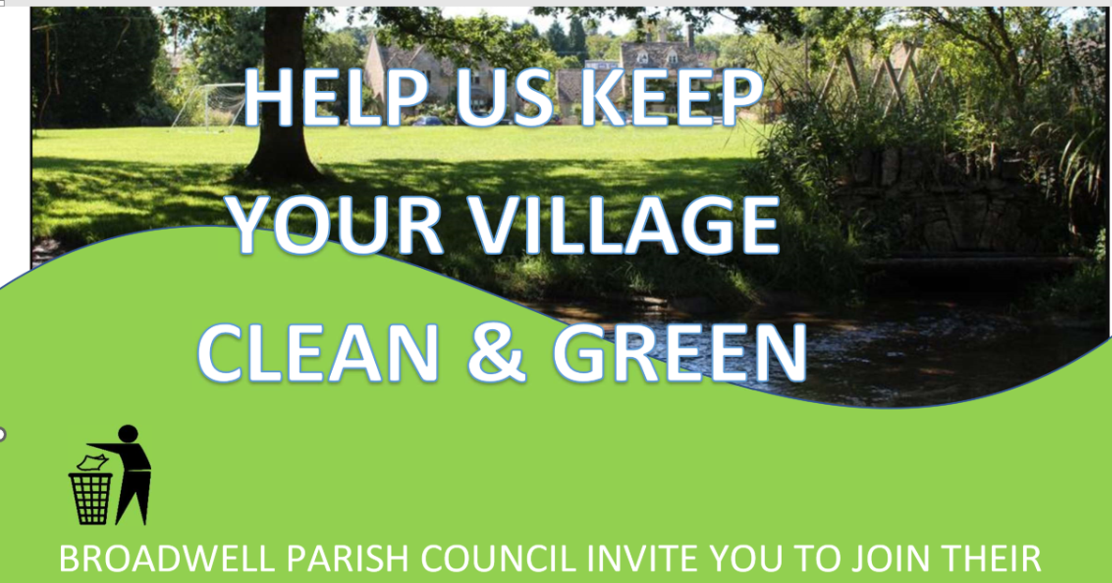

**Annual Litter Pick on Saturday, March 22nd at 10.00 starting at the Village Hall**

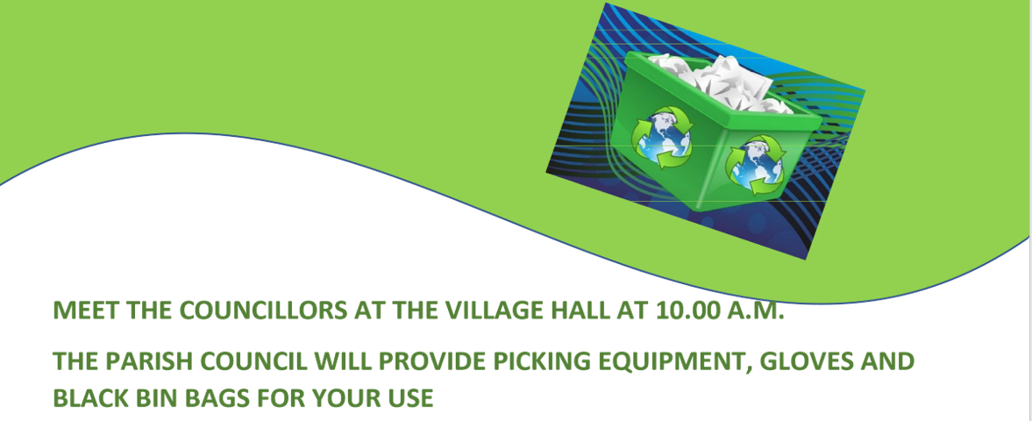

Further information can be obtained from Emma Ashton or the Clerk clerk@broadwellparishcouncil.gov.uk